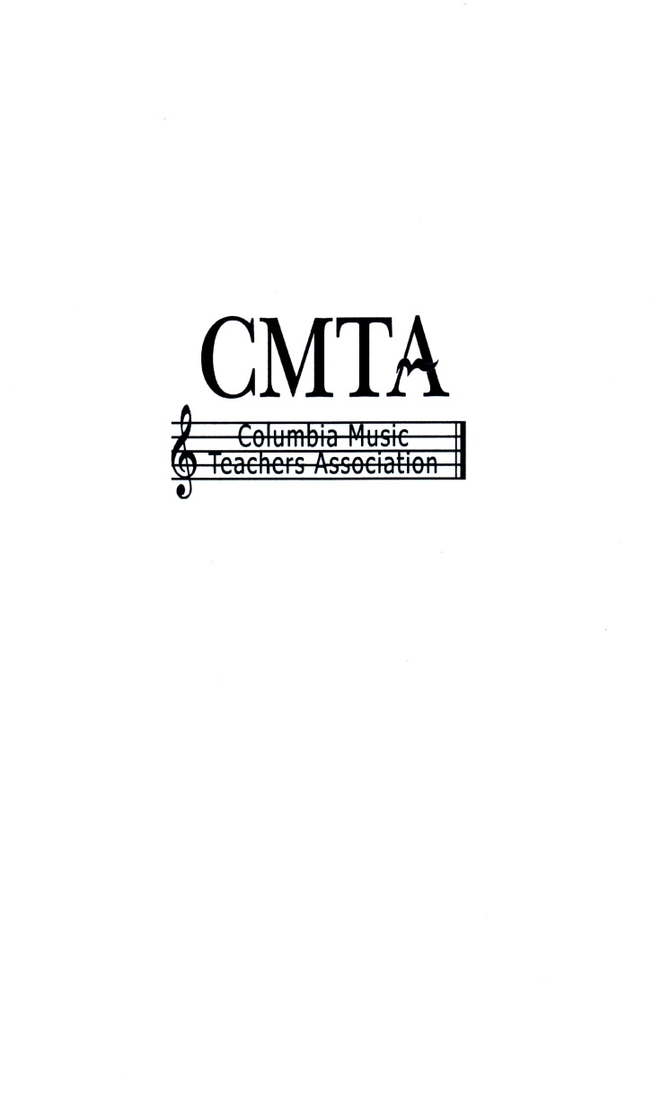

The Columbia Music Teachers Association is affiliated with the South Carolina Music Teachers Association and National Music Teachers Association. Our goal is to support excellence in music teaching and to encourage music students at all levels of study. CMTA offers monthly meetings for teachers featuring presentations by professional music educators, specialists, and performing artists. CMTA provides opportunities for music students throughout the year including music festivals, masterclasses, and scholarship auditions. Additional information about CMTA may be found by visiting columbiamusic.org
Your generous donations to the Columbia Music Teachers Association are appreciated! We invite individuals, businesses, and organizations to contribute to the fund. Donors at the following levels will be recognized at our CMTA Scholarship Auditions Honors Recital verbally as well as in the printed program and also on our CMTA website:
Patron ($1,000 +)
Featured Sponsor ($500 - $999)
Sustainer ($250-$499)
Contributor ($150-$249)
Supporter ($50-$149)

CMTA is a 501(c)(3) organization. Your tax deductible contribution may be made by check to Columbia Music Teachers Associations. Please complete the CMTA Donor Form and mail to: Helena Meetze, 613 Hatrick Rd, Columbia SC, 29209.

CMTA Donor Form
Date: __________________________

Name
Address
E-mail
Phone

Preferred name, business, or organization for donor recognition in the CMTA Scholarship Auditions Honors Recital program and CMTA website:
___________________________________________________________________________
(Optional)
In Honor of:_______________________________________________________
In Memory of: _____________________________________________________

CMTA is a 501(c)(3) organization. Your tax deductible contribution may be made by check to Columbia Music Teachers Associations. Please complete the CMTA Donor form and mail to: Helena Meetze, 613 Hatrick Rd, Columbia SC, 29209.

